VISVESVARAYA TECHNOLOGICAL UNIVERSITY
“JnanaSangama”, Belgaum -590014, Karnataka.


LAB REPORT

On

ANALYSIS AND DESIGN OF ALGORITHMS (23CS4PCADA)

Submitted by

Kushagra Siddha(1BF24CS154)

in partial fulfillment for the award of the degree of

BACHELOR OF ENGINEERING in COMPUTER SCIENCE AND ENGINEERING


B.M.S. COLLEGE OF ENGINEERING (Autonomous Institution under VTU) BENGALURU-560019
February to June 2026

B. M. S. College of Engineering,
Bull Temple Road, Bangalore 560019
(Affiliated To Visvesvaraya Technological University, Belgaum) Department of Computer Science and Engineering



CERTIFICATE

This is to certify that the Lab work entitled “ANALYSIS AND DESIGN OF
ALGORITHMS” carried out by Kushagra Siddha(1BF24CS154), who is bonafide student of B. M. S. College of Engineering. It is in partial fulfillment for the award of Bachelor of Engineering in Computer Science and Engineering of the Visvesvaraya Technological University, Belgaum during the year 2025-26. The Lab report has been approved as it satisfies the academic requirements in respect of Analysis and Design of Algorithms Lab - (23CS4PCADA) work prescribed for the said degree.

Proff. Pallavi CV Dr. Kavitha Sooda
Assistant Professor Professor and Head
Department of CSE Department of CSE
BMSCE, Bengaluru BMSCE, Bengaluru

Index Sheet
Sl.  No. | Experiment Title | Page No.
1 | Write program to obtain the Topological ordering of vertices in a given digraph. | 04
2 | Implement Johnson Trotter algorithm to generate permutations. | 09
3 | Sort a given set of N integer elements using Merge Sort technique and compute its time taken. Run the program for different values of N and record the time taken to sort. | 12
4 | Sort a given set of N integer elements using Quick Sort technique and compute its time taken. | 17
5 | Sort a given set of N integer elements using Heap Sort technique and compute its time taken. | 22
6 | Implement 0/1 Knapsack problem using dynamic programming. (5 Marks) | 25
7 | Implement All Pair Shortest paths problem using Floyd’s algorithm. | 29
8 | - Find Minimum Cost Spanning Tree of a given undirected graph using Prim’s algorithm.  - Find Minimum Cost Spanning Tree of a given undirected graph using Kruskal’s algorithm. | 33  35
9 | Implement Fractional Knapsack using Greedy technique. | 38
10 | From a given vertex in a weighted connected graph, find shortest paths to other vertices using Dijkstra’s algorithm. | 41
11 | Implement “N-Queens Problem” using Backtracking. | 43

Course outcomes:
CO1 | Analyze time complexity of algorithms using asymptotic notations.
CO2 | Apply various algorithm design techniques for the given problem.
CO3 | Evaluate the appropriate algorithm/design technique for solving a given problem.
CO4 | Conduct practical experiments by applying appropriate algorithm design technique to solve problems.

Lab Program 1:
Write program to obtain the Topological ordering of vertices in a given digraph.

Code:
#include <stdio.h>

#define MAX 10

int main() {
int n;
int graph[MAX][MAX];
int indegree[MAX] = {0};
int visited[MAX] = {0};

printf("Enter number of vertices: ");
scanf("%d", &n);

printf("Enter adjacency matrix:\n");
for (int i = 0; i < n; i++) {
for (int j = 0; j < n; j++) {
scanf("%d", &graph[i][j]);

if (graph[i][j] == 1)
indegree[j]++;
}
}

printf("\nTopological Ordering:\n");

for (int count = 0; count < n; count++) {

for (int i = 0; i < n; i++) {

if (indegree[i] == 0 && !visited[i]) {

printf("%d ", i);
visited[i] = 1;

// Remove outgoing edges
for (int j = 0; j < n; j++) {
if (graph[i][j] == 1)
indegree[j]--;
}

break;
}
}
}

printf("\n");

return 0;
}

Output:

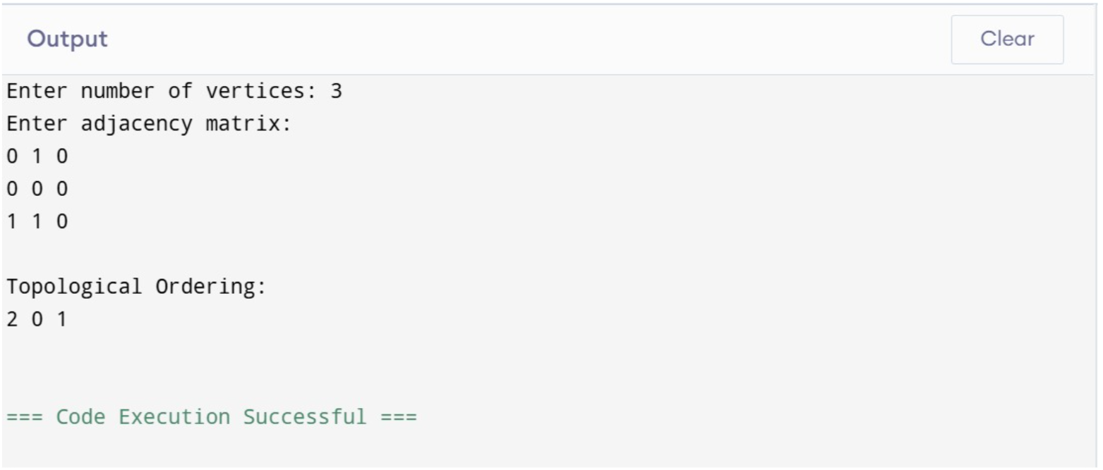

LeetCode Problem 207:
There are a total of numCourses courses you have to take, labeled from 0 to numCourses - 1. You are given an array prerequisites where prerequisites[i] = [a_{i}, b_{i}] indicates that you must take course b_{i} first if you want to take course a_{i}.
- For example, the pair [0, 1], indicates that to take course 0 you have to first take course 1.
Return true if you can finish all courses. Otherwise, return false.

Code:
#include <stdlib.h>
#include <stdbool.h>
bool canFinish(int numCourses, int** prerequisites, int prerequisitesSize, int* prerequisitesColSize) {
int *indegree = (int *)calloc(numCourses, sizeof(int));
int **adj = (int **)malloc(numCourses * sizeof(int *));
int *adjSize = (int *)calloc(numCourses, sizeof(int));
for (int i = 0; i < numCourses; i++) {
adj[i] = (int *)malloc(numCourses * sizeof(int));
}
for (int i = 0; i < prerequisitesSize; i++) {
int a = prerequisites[i][0];
int b = prerequisites[i][1];
adj[b][adjSize[b]++] = a;
indegree[a]++;
}
int *queue = (int *)malloc(numCourses * sizeof(int));
int front = 0, rear = 0;
for (int i = 0; i < numCourses; i++) {
if (indegree[i] == 0) {
queue[rear++] = i;
}
}

int count = 0;
while (front < rear) {
int course = queue[front++];
count++;
for (int i = 0; i < adjSize[course]; i++) {
int next = adj[course][i];
indegree[next]--;
if (indegree[next] == 0) {
queue[rear++] = next;
}
}
}
for (int i = 0; i < numCourses; i++) {
free(adj[i]);
}
free(adj);
free(adjSize);
free(indegree);
free(queue);
return count == numCourses;
}

ScreenShot from LeetCode:

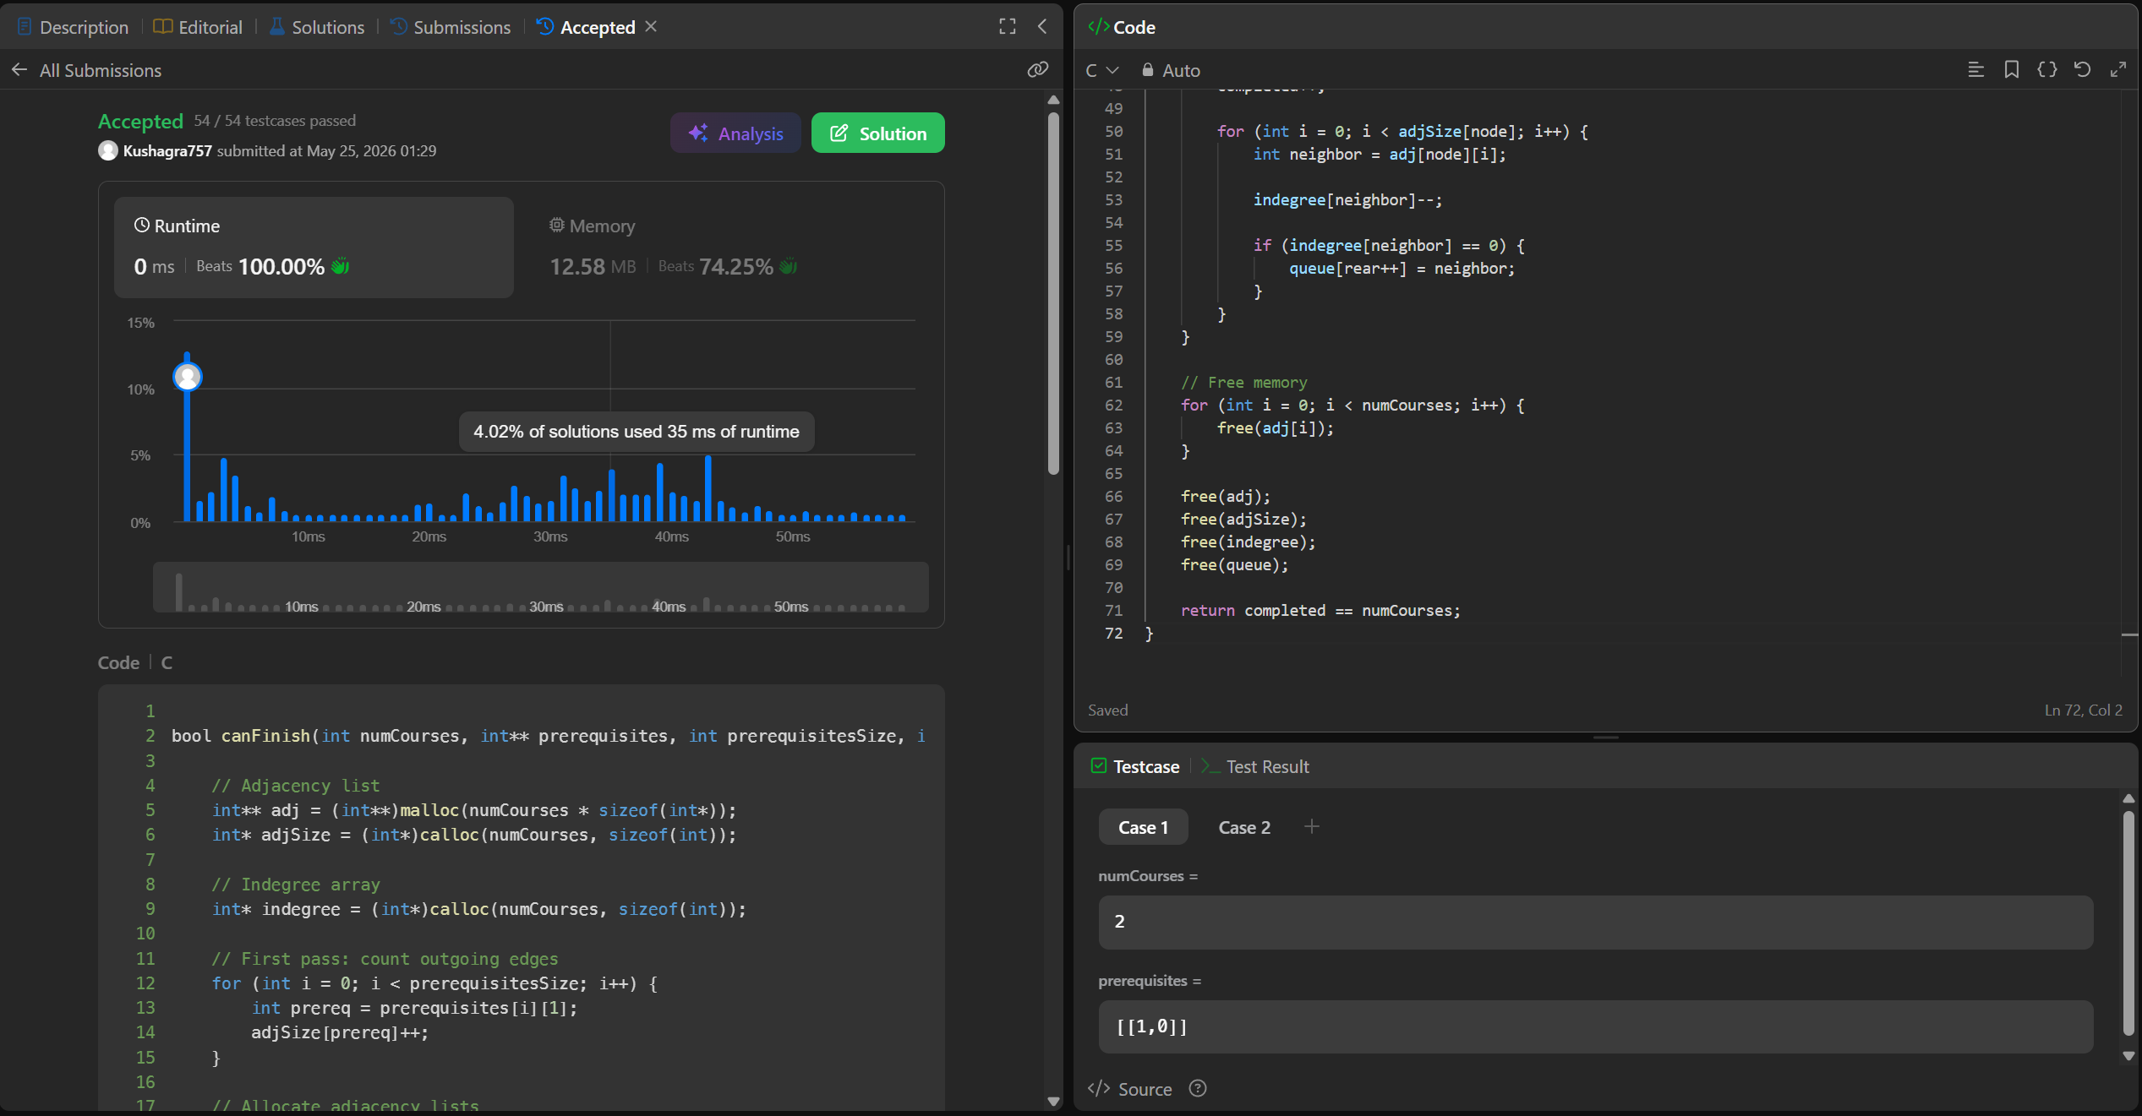
Lab Program 2:
Implement Johnson Trotter algorithm to generate permutations.

Code:
#include <stdio.h>
#define MAX 10
#define L -1
#define R 1
void print(int a[], int n) {
for (int i = 0; i < n; i++)
printf("%d ", a[i]);
printf("\n");
}
int main() {
int n, a[MAX], dir[MAX];
printf("Enter n: ");
scanf("%d", &n);
for (int i = 0; i < n; i++) {
a[i] = i + 1;
dir[i] = L;
}
print(a, n);
while (1) {
int mobile = 0, pos = -1;
for (int i = 0; i < n; i++) {
if (dir[i] == L && i > 0 &&
a[i] > a[i-1] && a[i] > mobile) {
mobile = a[i];
pos = i;
}
if (dir[i] == R && i < n-1 &&
a[i] > a[i+1] && a[i] > mobile) {
mobile = a[i];
pos = i;
}
}
if (mobile == 0)
break;
int next = pos + dir[pos];
int t = a[pos];
a[pos] = a[next];
a[next] = t;
t = dir[pos];
dir[pos] = dir[next];
dir[next] = t;
for (int i = 0; i < n; i++)
if (a[i] > mobile)
dir[i] *= -1;
print(a, n);
}
return 0;
}

Output:
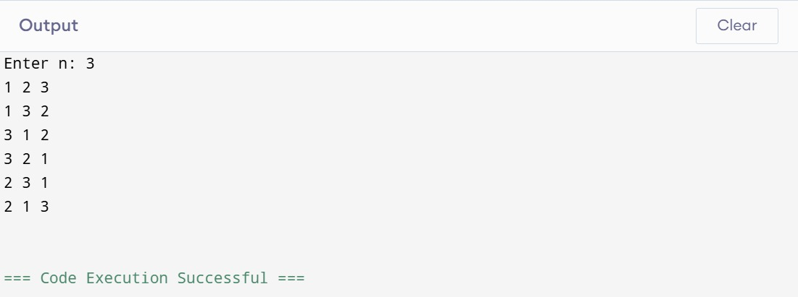

Lab Program:3
Sort a given set of N integer elements using Merge Sort technique and compute its time taken. Run the program for different values of N and record the time taken to sort.
Code:
#include <stdio.h>
#include <time.h>
#define MAX 100000
void merge(int a[], int low, int mid, int high)
{
int i = low, j = mid + 1, k = low;
int temp[MAX];
while (i <= mid && j <= high)
{
if (a[i] <= a[j])
temp[k++] = a[i++];
else
temp[k++] = a[j++];
}
while (i <= mid)
temp[k++] = a[i++];
while (j <= high)
temp[k++] = a[j++];
for (i = low; i <= high; i++)
a[i] = temp[i];
}
void mergeSort(int a[], int low, int high)
{
if (low < high)
{
int mid = (low + high) / 2;
mergeSort(a, low, mid);
mergeSort(a, mid + 1, high);
merge(a, low, mid, high);
}
}
int main()
{
int a[MAX], n, i;
clock_t start, end;
double time_taken;
printf("Enter number of elements: ");
scanf("%d", &n);
printf("Enter elements:\n");
for (i = 0; i < n; i++)
scanf("%d", &a[i]);
start = clock();
mergeSort(a, 0, n - 1);
end = clock();
time_taken = ((double)(end - start)*1000.0) / CLOCKS_PER_SEC;
printf("\nSorted array:\n");
for (i = 0; i < n; i++)
printf("%d ", a[i]);
printf("\n\nTime taken = %f seconds\n", time_taken);
return 0;
}

Output:

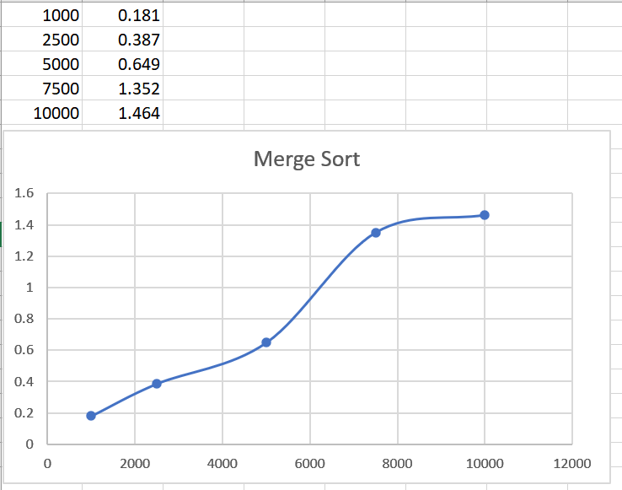

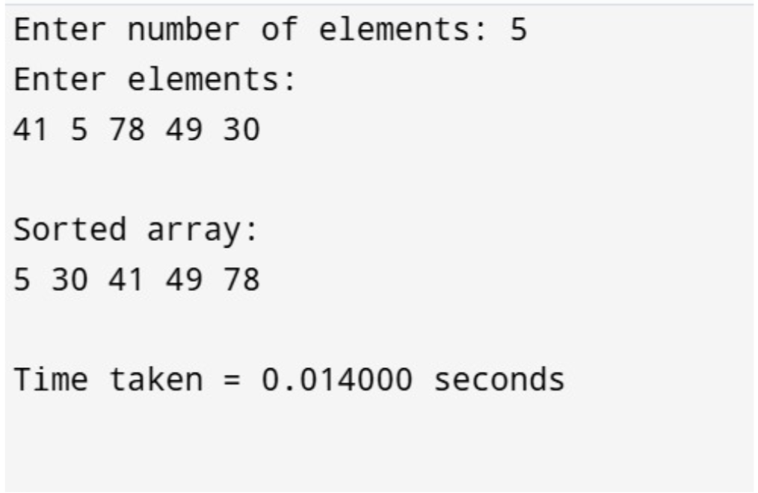

LeetCode Problem 21:
You are given the heads of two sorted linked lists list1 and list2.
Merge the two lists into one sorted list. The list should be made by splicing together the nodes of the first two lists.
Return the head of the merged linked list.

Code:
/**
* Definition for singly-linked list.
* struct ListNode {
* int val;
* struct ListNode *next;
* };
*/
struct ListNode* mergeTwoLists(struct ListNode* list1, struct ListNode* list2) {
struct ListNode *temp=list1;
struct ListNode *i,*j;
int temp2;
if(list1==NULL){
list1=list2;
return list1;
}
while(temp ->next != NULL){
temp=temp->next;
}
temp->next=list2;
for(i=list1;i!=NULL;i=i->next){
for(j=i->next;j!=NULL;j=j->next){
if(i->val>j->val){
temp2=j->val;
j->val=i->val;
i->val=temp2;
}
}
}
return list1;
}

ScreenShot from Leetcode:

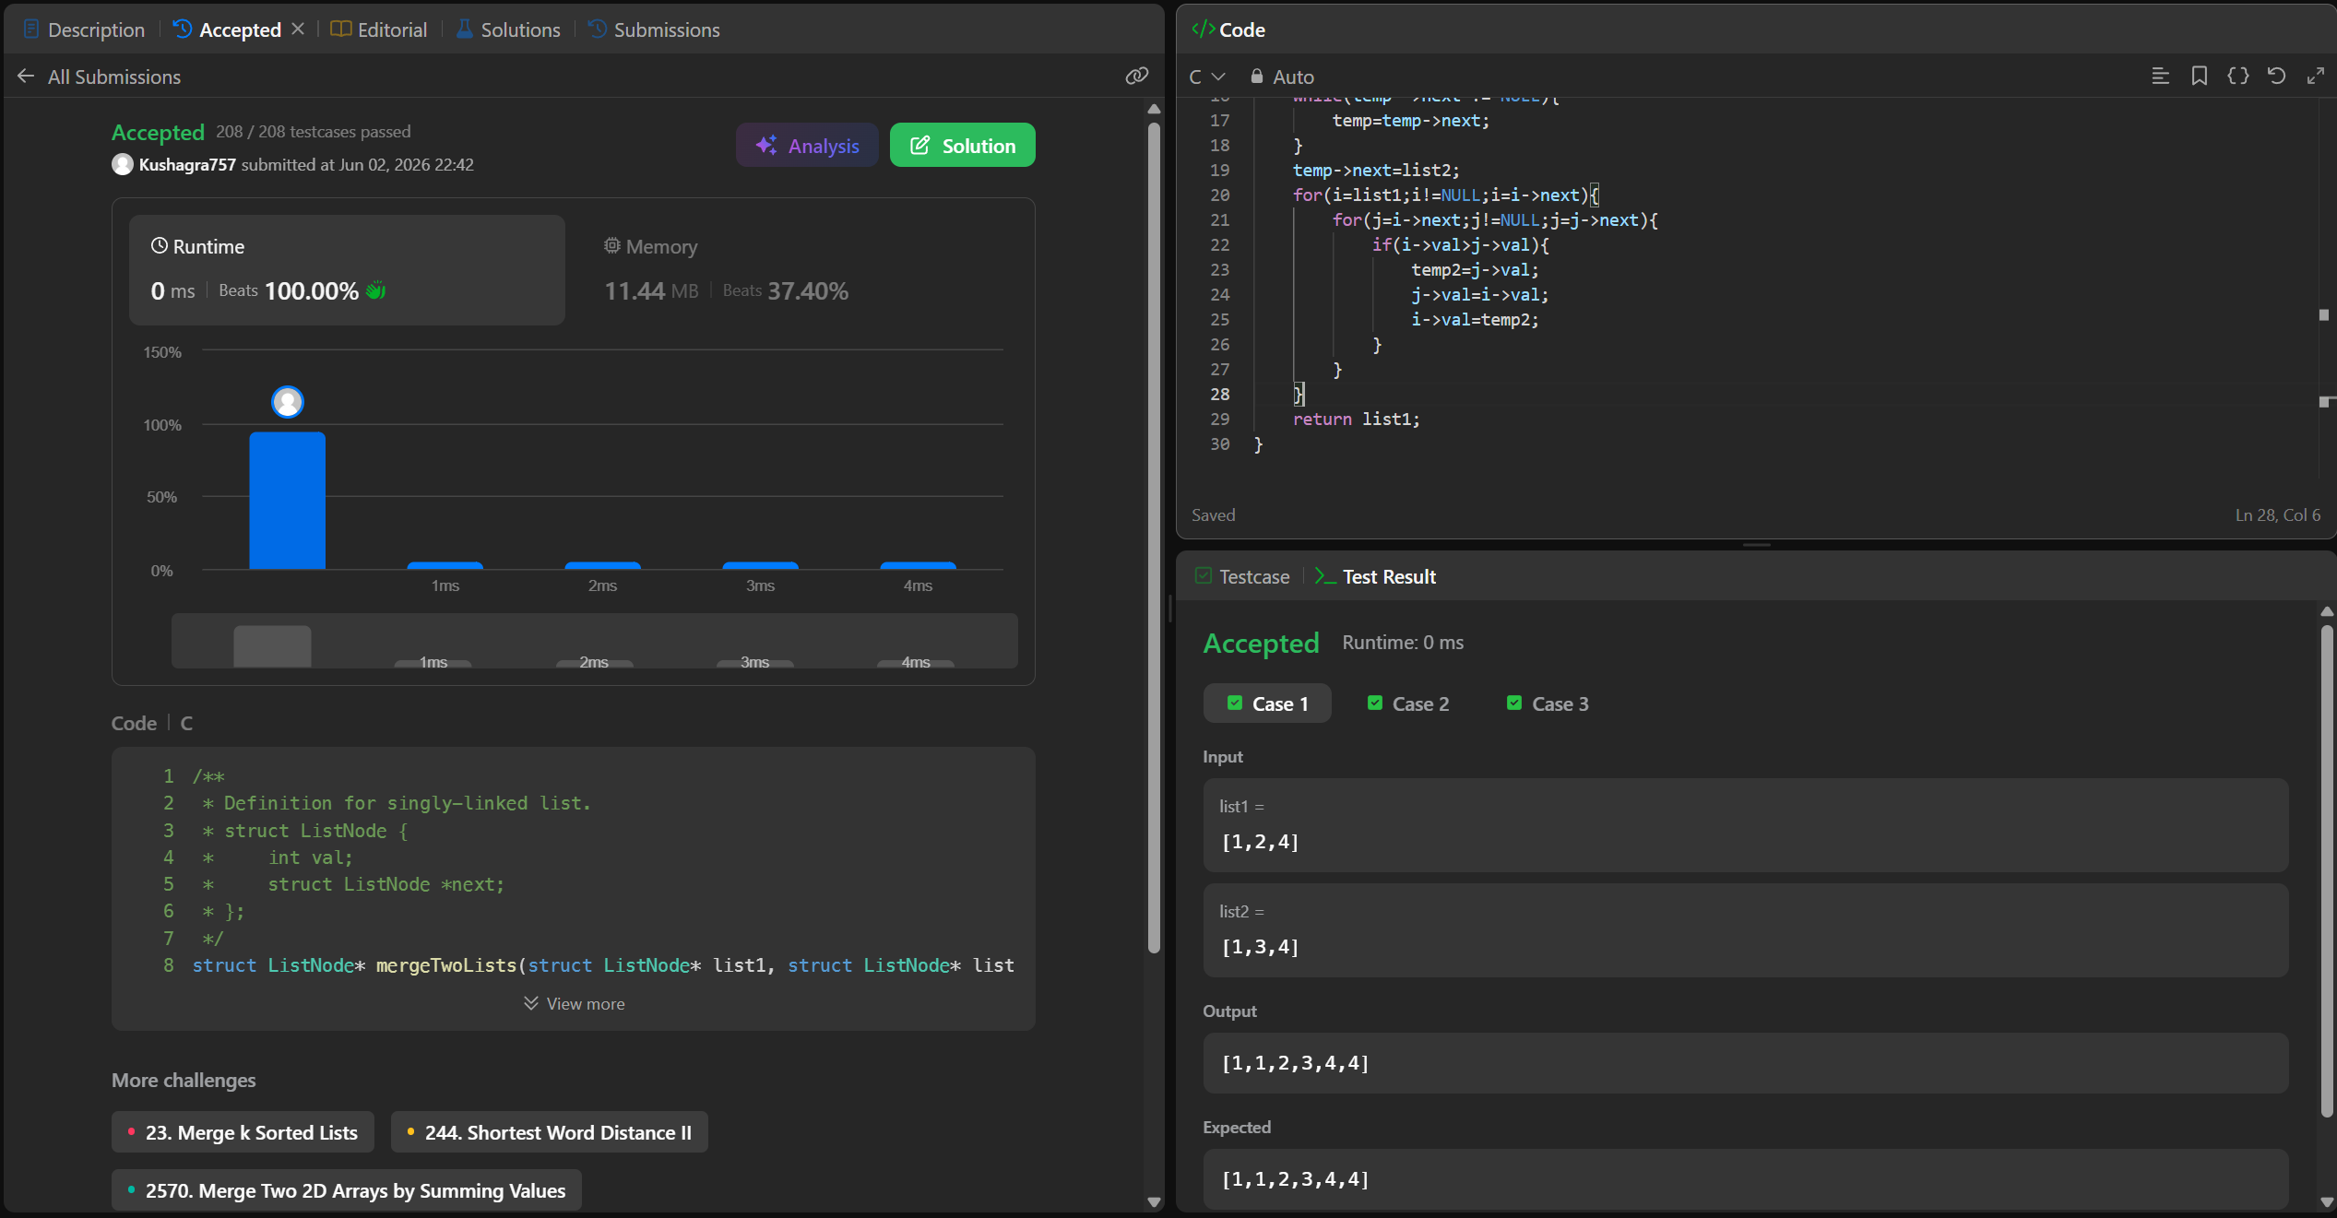

Lab Program:4
Sort a given set of N integer elements using Quick Sort technique and compute its time taken.

Code:

#include <stdio.h>
#include <stdlib.h>
#include <time.h>

void swap(int* a, int* b) {
int t = *a;
*a = *b;
*b = t;
}

int partition(int arr[], int low, int high) {
int pivot = arr[low];
int i = low;
int j = high;

while (i < j) {

while (arr[i] <= pivot && i <= high - 1) {
i++;
}

while (arr[j] > pivot && j >= low + 1) {
j--;
}

if (i < j) {
swap(&arr[i], &arr[j]);
}
}

swap(&arr[low], &arr[j]);
return j;
}

void quickSort(int arr[], int low, int high) {
if (low < high) {
int pi = partition(arr, low, high);
quickSort(arr, low, pi - 1);
quickSort(arr, pi + 1, high);
}
}

int main() {
int n;
printf("Enter number of elements: ");
if (scanf("%d", &n) != 1) return 1;

int *arr = (int*)malloc(n * sizeof(int));

srand(time(0));
for (int i = 0; i < n; i++) {
arr[i] = rand() % 10000;
}

clock_t start = clock();
quickSort(arr, 0, n - 1);
clock_t end = clock();

double cpu_time_used = ((double)(end - start)) / CLOCKS_PER_SEC;

printf("\nSorting complete.\n");
printf("Time taken: %f seconds\n", cpu_time_used);

}

Output:
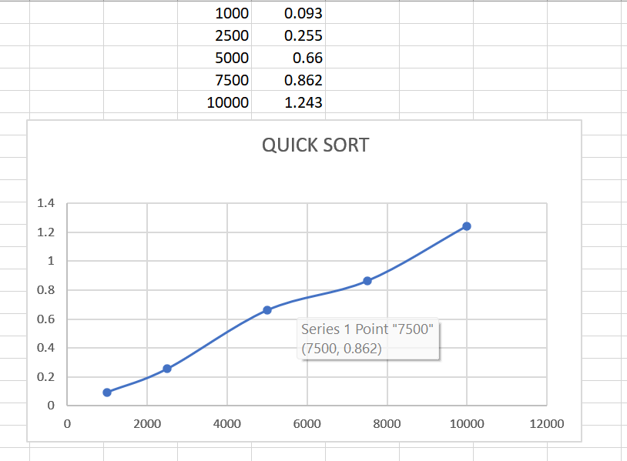
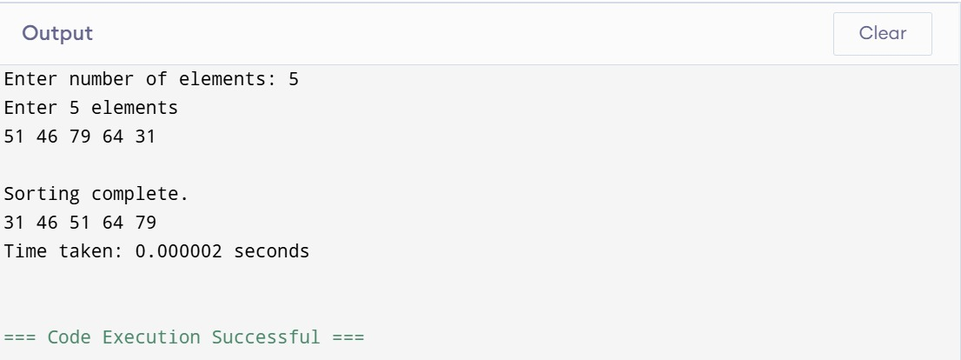

LeetCode Problem:997
In a town, there are n people labeled from 1 to n. There is a rumor that one of these people is secretly the town judge.
If the town judge exists, then:
- The town judge trusts nobody.
- Everybody (except for the town judge) trusts the town judge.
- There is exactly one person that satisfies properties 1 and 2.
You are given an array trust where trust[i] = [a_{i}, b_{i}] representing that the person labeled a_{i} trusts the person labeled b_{i}. If a trust relationship does not exist in trust array, then such a trust relationship does not exist.
Return the label of the town judge if the town judge exists and can be identified, or return -1 otherwise.
Code:
int findJudge(int n, int** trust, int trustSize, int* trustColSize) {
int count[n + 1];

for (int i = 0; i <= n; i++)
count[i] = 0;

for (int i = 0; i < trustSize; i++) {
int a = trust[i][0];
int b = trust[i][1];

count[a]--;
count[b]++;
}

for (int i = 1; i <= n; i++) {
if (count[i] == n - 1)
return i;
}

return -1;
}
ScreenShot from Leetcode:

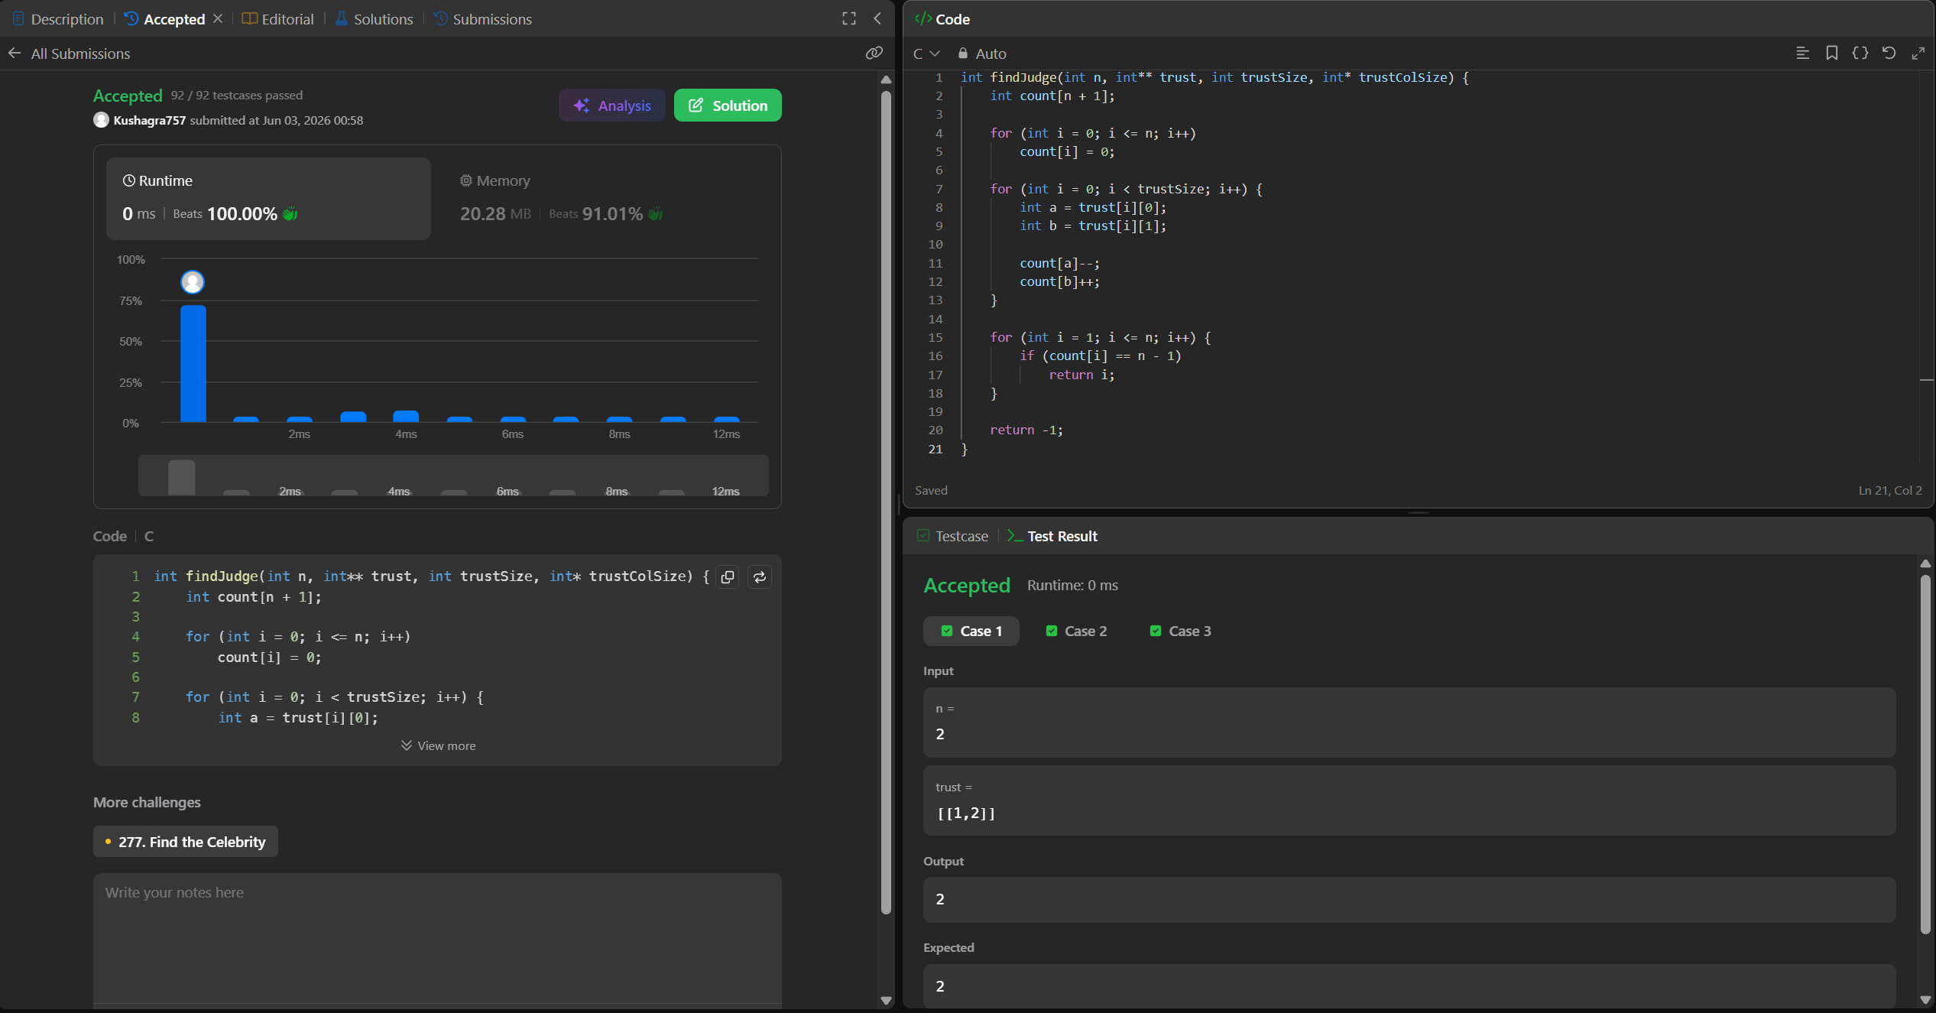

Lab Program:5
Sort a given set of N integer elements using Heap Sort technique and compute its time taken.

Code:

#include <stdio.h>
#include <time.h>

void heapify(int a[], int n, int i) {
int largest = i;
int left = 2 * i + 1;
int right = 2 * i + 2;

if (left < n && a[left] > a[largest])
largest = left;

if (right < n && a[right] > a[largest])
largest = right;

if (largest != i) {
int temp = a[i];
a[i] = a[largest];
a[largest] = temp;

heapify(a, n, largest);
}
}

void heapSort(int a[], int n) {

for (int i = n/2 - 1; i >= 0; i--)
heapify(a, n, i);

for (int i = n-1; i > 0; i--) {

int temp = a[0];
a[0] = a[i];
a[i] = temp;

heapify(a, i, 0);
}
}

int main() {
int n;

printf("Enter number of elements: ");
scanf("%d", &n);

int a[n];

printf("Enter elements:\n");
for (int i = 0; i < n; i++)
scanf("%d", &a[i]);

clock_t start, end;

start = clock();

heapSort(a, n);

end = clock();

printf("\nSorted Array:\n");
for (int i = 0; i < n; i++)
printf("%d ", a[i]);

double time_taken =
((double)(end - start)) / CLOCKS_PER_SEC;

printf("\n\nTime Taken = %f seconds\n", time_taken);

return 0;
}

Output:
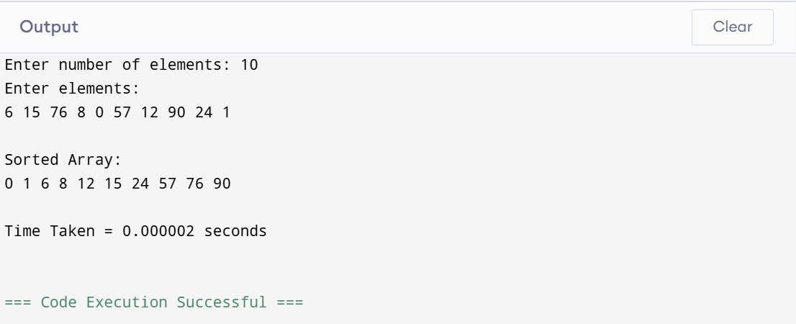

Lab Program:6
Implement 0/1 Knapsack problem using dynamic programming

Code:

#include <stdio.h>
int max(int a, int b) {
return (a > b) ? a : b;
}
int main() {
int n, W;
printf("Enter number of items: ");
scanf("%d", &n);

int wt[n], val[n];
printf("Enter weights:\n");

for (int i = 0; i < n; i++)
scanf("%d", &wt[i]);
printf("Enter values:\n");

for (int i = 0; i < n; i++)
scanf("%d", &val[i]);

printf("Enter capacity: ");
scanf("%d", &W);

int dp[n+1][W+1];

for (int i = 0; i <= n; i++) {
for (int w = 0; w <= W; w++) {

if (i == 0 || w == 0)
dp[i][w] = 0;

else if (wt[i-1] <= w)
dp[i][w] = max(
val[i-1] + dp[i-1][w - wt[i-1]],
dp[i-1][w]
);
else
dp[i][w] = dp[i-1][w];
}
}
printf("\nMaximum Value = %d\n", dp[n][W]);
return 0;
}
Output:
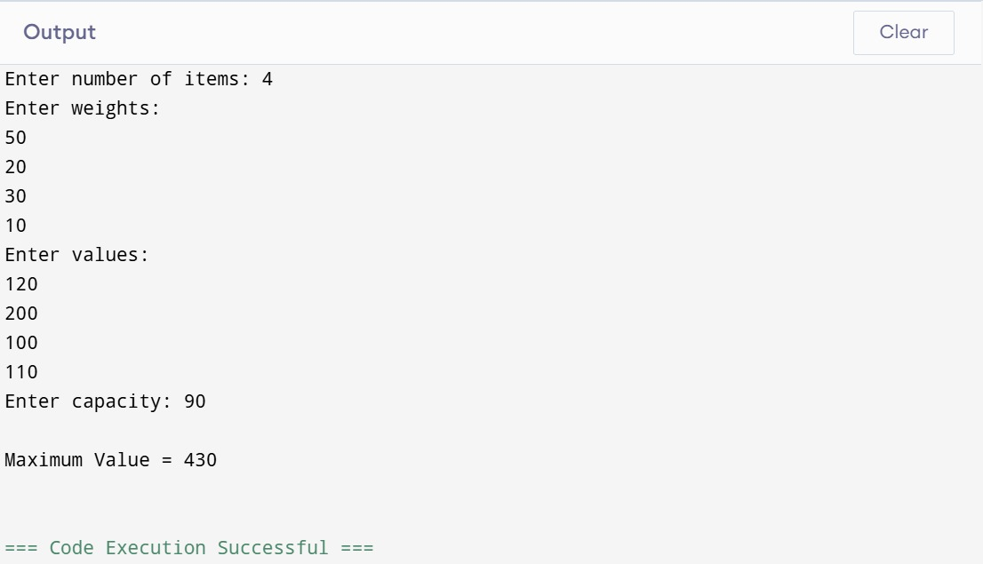

LeetCode Problem:416

Given an integer array nums, return true if you can partition the array into two subsets such that the sum of the elements in both subsets is equal or false otherwise.

Code:

bool canPartition(int* nums, int numsSize) {
int sum = 0;

for (int i = 0; i < numsSize; i++) {
sum += nums[i];
}

if (sum % 2 != 0)
return false;

int target = sum / 2;

bool *dp = (bool *)calloc(target + 1, sizeof(bool));
dp[0] = true;

for (int i = 0; i < numsSize; i++) {
for (int j = target; j >= nums[i]; j--) {
dp[j] = dp[j] || dp[j - nums[i]];
}
}

bool result = dp[target];
free(dp);

return result;
}

ScreenShot from LeetCode:

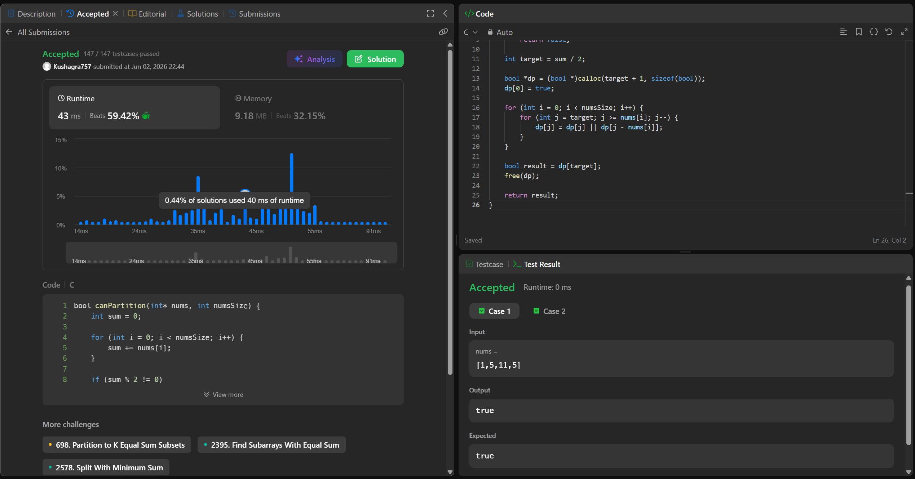

Lab Program:7
Implement All Pair Shortest paths problem using Floyd’s algorithm

Code:

#include <stdio.h>
#define MAX 100
#define INF 99999

void floyd(int graph[MAX][MAX], int n) {
int dist[MAX][MAX];

for (int i = 0; i < n; i++)
for (int j = 0; j < n; j++)
dist[i][j] = graph[i][j];

for (int k = 0; k < n; k++) {
for (int i = 0; i < n; i++) {
for (int j = 0; j < n; j++) {
if (dist[i][k] + dist[k][j] < dist[i][j]) {
dist[i][j] = dist[i][k] + dist[k][j];
}
}
}
}

printf("\nAll-Pairs Shortest Path Matrix:\n");
for (int i = 0; i < n; i++) {
for (int j = 0; j < n; j++) {
if (dist[i][j] == INF)
printf("INF ");
else
printf("%3d ", dist[i][j]);
}
printf("\n");
}
}

int main() {
int n, graph[MAX][MAX];

printf("Enter number of vertices: ");
scanf("%d", &n);

printf("Enter adjacency matrix (use 99999 for INF):\n");
for (int i = 0; i < n; i++)
for (int j = 0; j < n; j++)
scanf("%d", &graph[i][j]);

floyd(graph, n);

return 0;
}

Output:
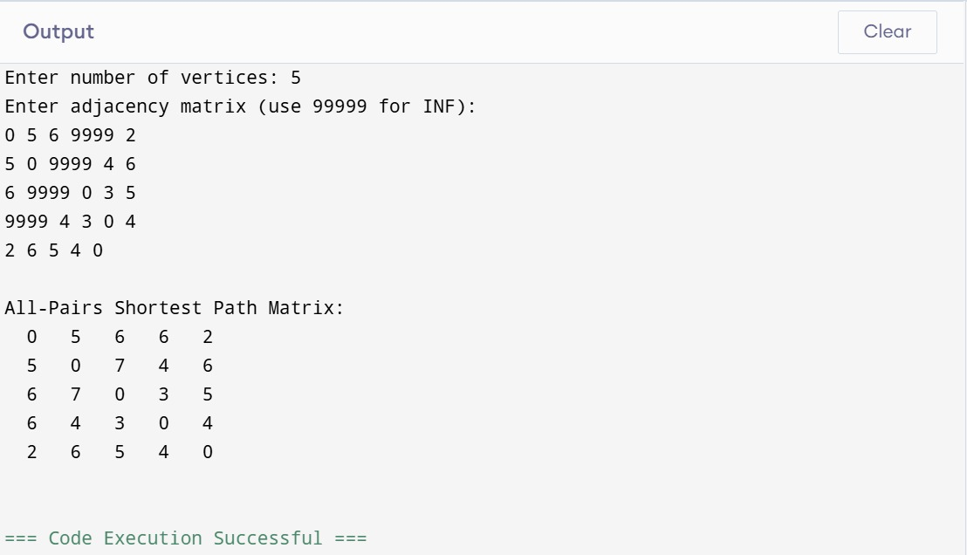

LeetCode Problem:783
Given the root of a Binary Search Tree (BST), return the minimum difference between the values of any two different nodes in the tree.

Code:
void inorder(struct TreeNode* root, int* prev, int* ans) {
if (root == NULL)
return;
inorder(root->left, prev, ans);
if (*prev != -1) {
int diff = root->val - *prev;
if (diff < *ans)
*ans = diff;
}
*prev = root->val;
inorder(root->right, prev, ans);
}
int minDiffInBST(struct TreeNode* root) {
int prev = -1;
int ans = 1000000;
inorder(root, &prev, &ans);
return ans;
}

ScreenShot from Leetcode:

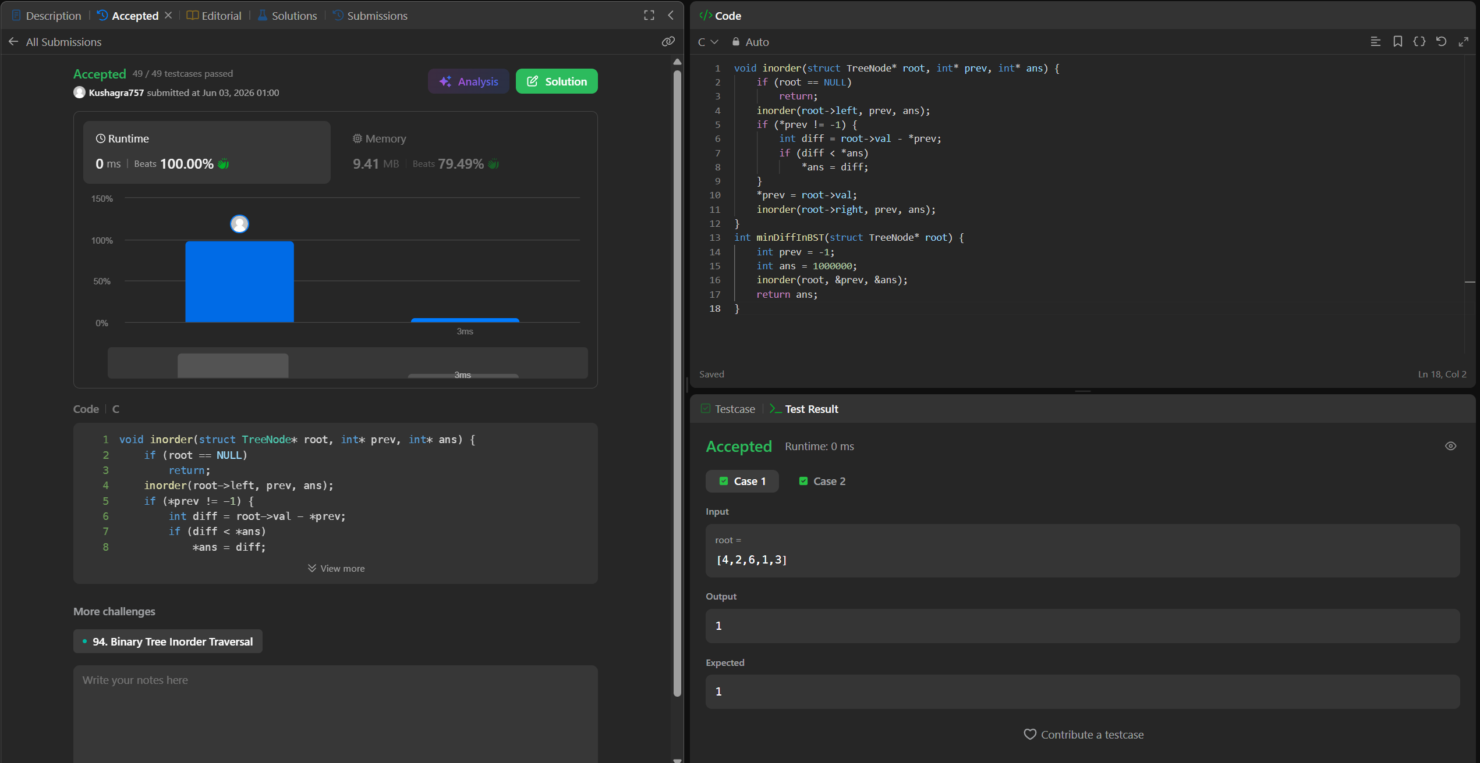

Lab Program:8a
Find Minimum Cost Spanning Tree of a given undirected graph using Prim’s algorithm

Code:

#include <stdio.h>

#define MAX 10
#define INF 99999

int main() {
int n;
int graph[MAX][MAX];
int selected[MAX] = {0};

int edges = 0;
int minCost = 0;

printf("Enter number of vertices: ");
scanf("%d", &n);

printf("Enter adjacency matrix (0 for no edge):\n");
for (int i = 0; i < n; i++)
for (int j = 0; j < n; j++)
scanf("%d", &graph[i][j]);

selected[0] = 1;

printf("\nEdges in MST:\n");

while (edges < n - 1) {

int min = INF;
int x = -1, y = -1;

for (int i = 0; i < n; i++) {

if (selected[i]) {

for (int j = 0; j < n; j++) {

if (!selected[j] &&
graph[i][j] &&
graph[i][j] < min) {

min = graph[i][j];
x = i;
y = j;
}
}
}
}

printf("%d - %d : %d\n", x, y, graph[x][y]);

minCost += graph[x][y];
selected[y] = 1;
edges++;
}

printf("\nMinimum Cost = %d\n", minCost);

return 0;
}

Output:
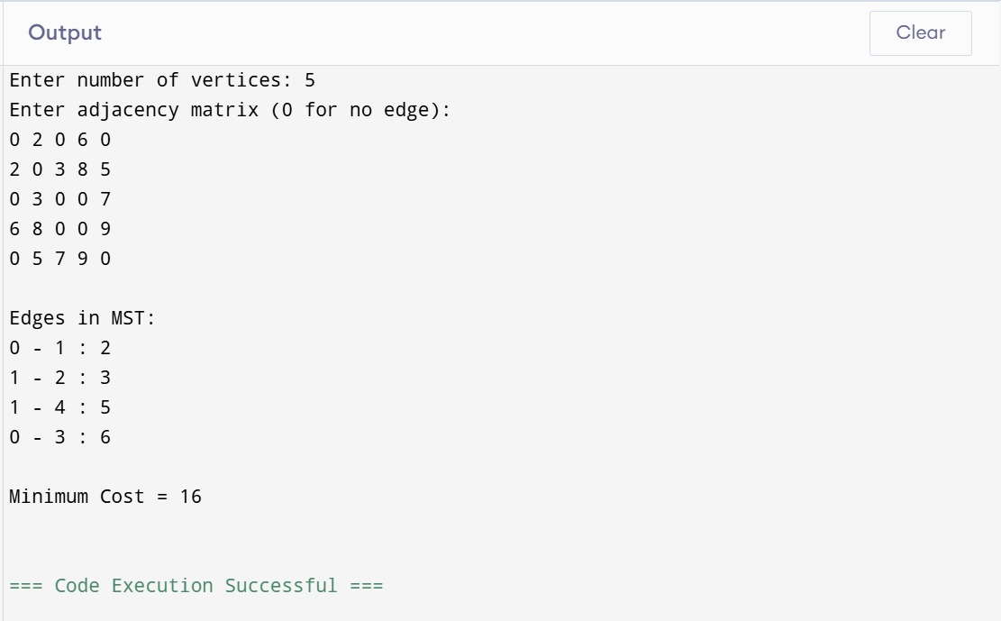

Lab Program:8b
Find Minimum Cost Spanning Tree of a given undirected graph using Kruskal’s algorithm.

Code:

#include <stdio.h>

#define MAX 10

struct Edge {
int u, v, w;
};

int parent[MAX];

// Find parent
int find(int i) {
while (parent[i] != i)
i = parent[i];
return i;
}

void unite(int a, int b) {
parent[a] = b;
}

void sort(struct Edge e[], int n) {
for (int i = 0; i < n - 1; i++) {
for (int j = 0; j < n - i - 1; j++) {
if (e[j].w > e[j + 1].w) {
struct Edge temp = e[j];
e[j] = e[j + 1];
e[j + 1] = temp;
}
}
}
}

int main() {
int n;
int graph[MAX][MAX];
struct Edge edges[MAX * MAX];

int edgeCount = 0;
int minCost = 0;

printf("Enter number of vertices: ");
scanf("%d", &n);

printf("Enter adjacency matrix (0 for no edge):\n");

for (int i = 0; i < n; i++) {
parent[i] = i;

for (int j = 0; j < n; j++) {
scanf("%d", &graph[i][j]);

if (graph[i][j] != 0 && i < j) {
edges[edgeCount].u = i;
edges[edgeCount].v = j;
edges[edgeCount].w = graph[i][j];
edgeCount++;
}
}
}

sort(edges, edgeCount);

printf("\nEdges in MST:\n");

int count = 0;

for (int i = 0; i < edgeCount && count < n - 1; i++) {

int u = find(edges[i].u);
int v = find(edges[i].v);

if (u != v) {
printf("%d - %d : %d\n",
edges[i].u,
edges[i].v,
edges[i].w);

minCost += edges[i].w;
unite(u, v);
count++;
}
}

printf("\nMinimum Cost = %d\n", minCost);

return 0;
}
Output:
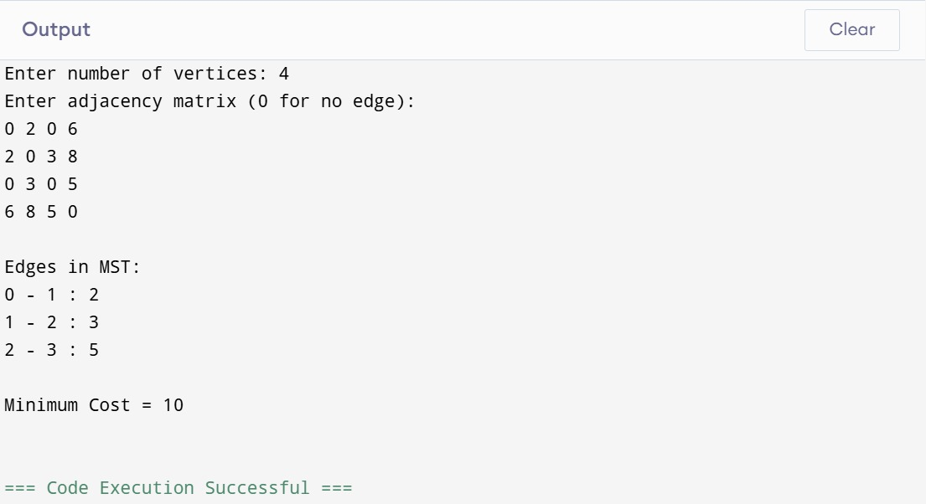

Lab Program:9
Implement Fractional Knapsack using Greedy technique

Code:

#include <stdio.h>

struct Item {
int weight, value;
float ratio;
};

void sort(struct Item arr[], int n) {
for (int i = 0; i < n-1; i++)
for (int j = 0; j < n-i-1; j++)
if (arr[j].ratio < arr[j+1].ratio) {
struct Item temp = arr[j];
arr[j] = arr[j+1];
arr[j+1] = temp;
}
}

int main() {
int n, capacity;
struct Item arr[100];

printf("Enter number of items: ");
scanf("%d", &n);

for (int i = 0; i < n; i++) {
printf("\nItem %d\n", i+1);
printf("Value: ");
scanf("%d", &arr[i].value);
printf("Weight: ");
scanf("%d", &arr[i].weight);
arr[i].ratio = (float)arr[i].value / arr[i].weight;
}

printf("\nEnter knapsack capacity: ");
scanf("%d", &capacity);

sort(arr, n);

float totalValue = 0.0;

printf("\nItems taken:\n");

for (int i = 0; i < n; i++) {
if (capacity == 0) break;

if (arr[i].weight <= capacity) {

capacity -= arr[i].weight;
totalValue += arr[i].value;
printf("Item %d -> FULL (Value = %d)\n", i+1, arr[i].value);
} else {

float fraction = (float)capacity / arr[i].weight;
totalValue += arr[i].value * fraction;
printf("Item %d -> %.2f fraction\n", i+1, fraction);
capacity = 0;
}
}

printf("\nMaximum Value = %.2f\n", totalValue);

return 0;
}

Output:
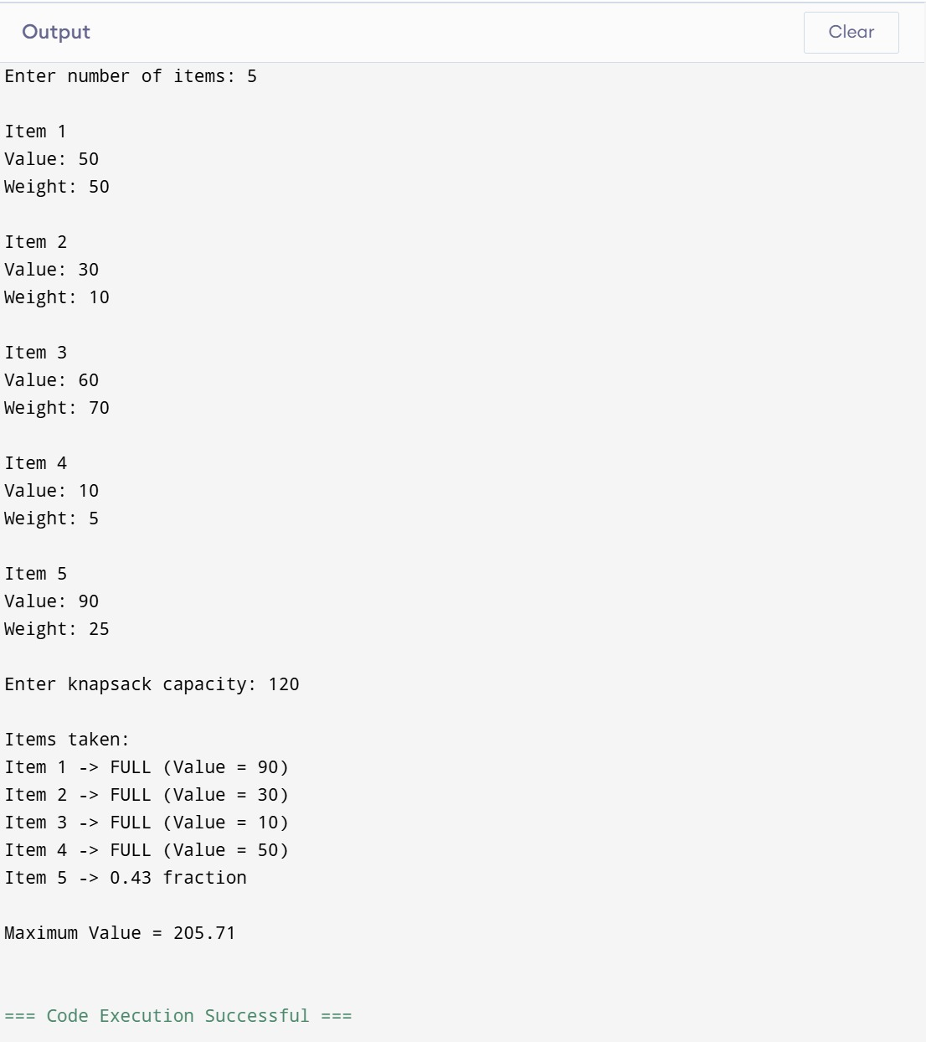

LeetCode Problem:11
You are given an integer array height of length n. There are n vertical lines drawn such that the two endpoints of the i^{th} line are (i, 0) and (i, height[i]).
Find two lines that together with the x-axis form a container, such that the container contains the most water.
Return the maximum amount of water a container can store.
Notice that you may not slant the container.

Code:

int maxArea(int* height, int heightSize) {
int left = 0;
int right = heightSize - 1;
int maxWater = 0;
while (left < right) {
int width = right - left;
int h = (height[left] < height[right]) ? height[left] : height[right];
int area = width * h;
if (area > maxWater)
maxWater = area;
if (height[left] < height[right])
left++;
else
right--;
}
return maxWater;
}
Output:

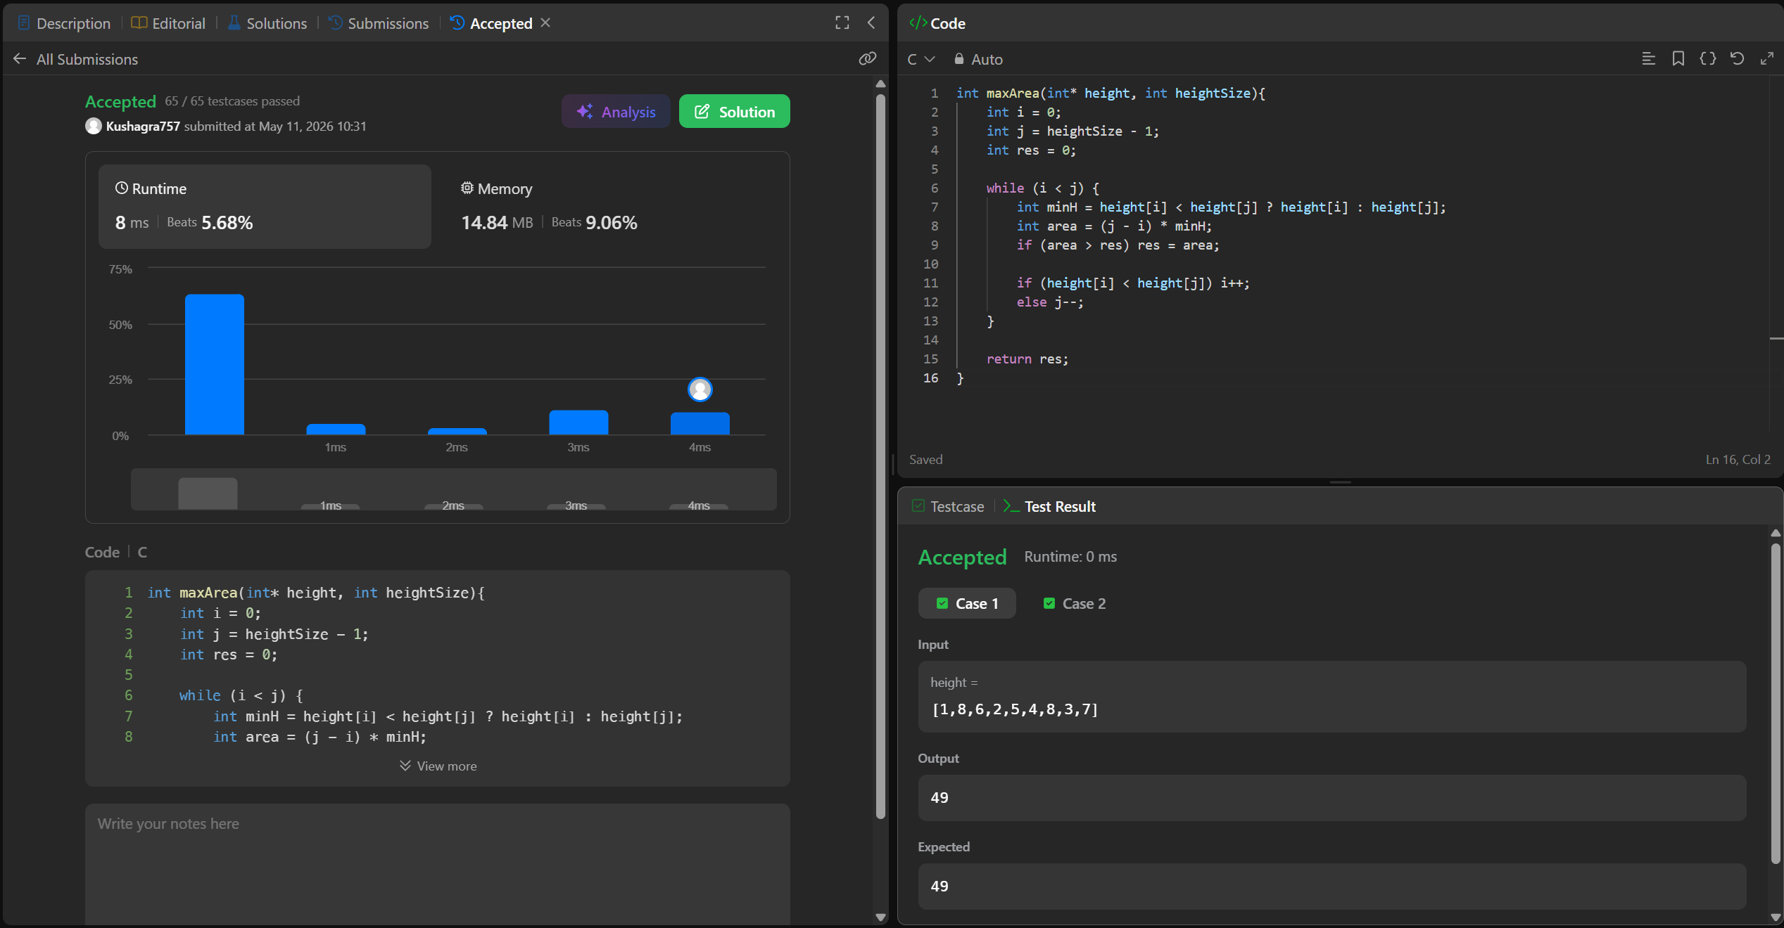

Lab Program:10
From a given vertex in a weighted connected graph, find shortest paths to other vertices using Dijkstra’s algorithm

Code:

#include <stdio.h>
#define MAX 100
#define INF 99999

int minDist(int dist[], int visited[], int n) {
int min = INF, index = -1;

for (int i = 0; i < n; i++) {
if (!visited[i] && dist[i] < min) {
min = dist[i];
index = i;
}
}
return index;
}

void dijkstra(int graph[MAX][MAX], int n, int src) {
int dist[MAX], visited[MAX];

for (int i = 0; i < n; i++) {
dist[i] = INF;
visited[i] = 0;
}
dist[src] = 0;

for (int i = 0; i < n-1; i++) {
int u = minDist(dist, visited, n);
visited[u] = 1;

for (int v = 0; v < n; v++) {
if (!visited[v] && graph[u][v] &&
dist[u] + graph[u][v] < dist[v]) {

dist[v] = dist[u] + graph[u][v];
}
}
}

printf("\nVertex\tDistance from Source\n");
for (int i = 0; i < n; i++)
printf("%d\t%d\n", i, dist[i]);
}

int main() {
int n, src;
int graph[MAX][MAX];

printf("Enter number of vertices: ");
scanf("%d", &n);

printf("Enter adjacency matrix (0 for no edge):\n");
for (int i = 0; i < n; i++)
for (int j = 0; j < n; j++)
scanf("%d", &graph[i][j]);

printf("Enter source vertex: ");
scanf("%d", &src);

dijkstra(graph, n, src);

return 0;
}

Output:
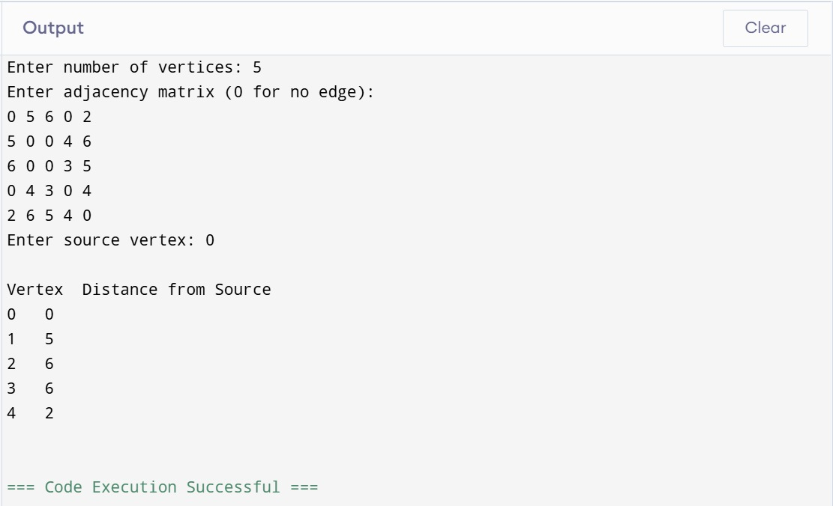

Lab Program:11
Implement “N-Queens Problem” using Backtracking

Code:

#include <stdio.h>
#include <stdlib.h>

int x[20], n;

int place(int k, int i) {
for (int j = 1; j < k; j++)
if (x[j] == i || abs(x[j] - i) == abs(j - k))
return 0;
return 1;
}

void queen(int k) {
for (int i = 1; i <= n; i++) {
if (place(k, i)) {
x[k] = i;
if (k == n) {
for (int j = 1; j <= n; j++)
printf("%d ", x[j]);
printf("\n");
} else
queen(k + 1);
}
}
}

int main() {
printf("Enter n: ");
scanf("%d", &n);
queen(1);
return 0;
}

Output:
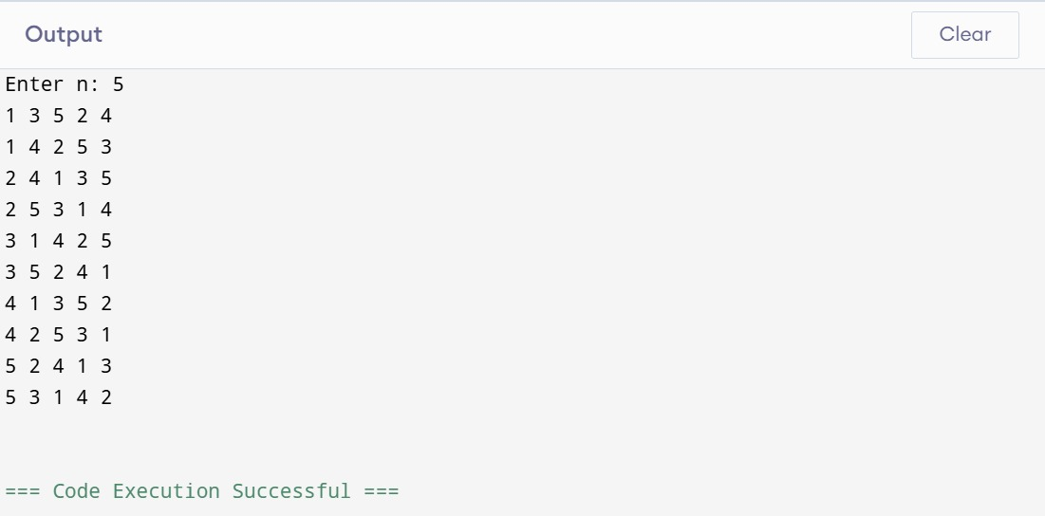

LeetCode Problem:704
Given an array of integers nums which is sorted in ascending order, and an integer target, write a function to search target in nums. If target exists, then return its index. Otherwise, return -1.
You must write an algorithm with O(log n) runtime complexity.

Code:

int search(int* nums, int numsSize, int target) {
int left = 0;
int right = numsSize - 1;

while (left <= right) {
int mid = left + (right - left) / 2;
if (nums[mid] == target)
return mid;
else if (nums[mid] < target)
left = mid + 1;
else
right = mid - 1;
}

return -1;
}

ScreenShot from LeetCode:

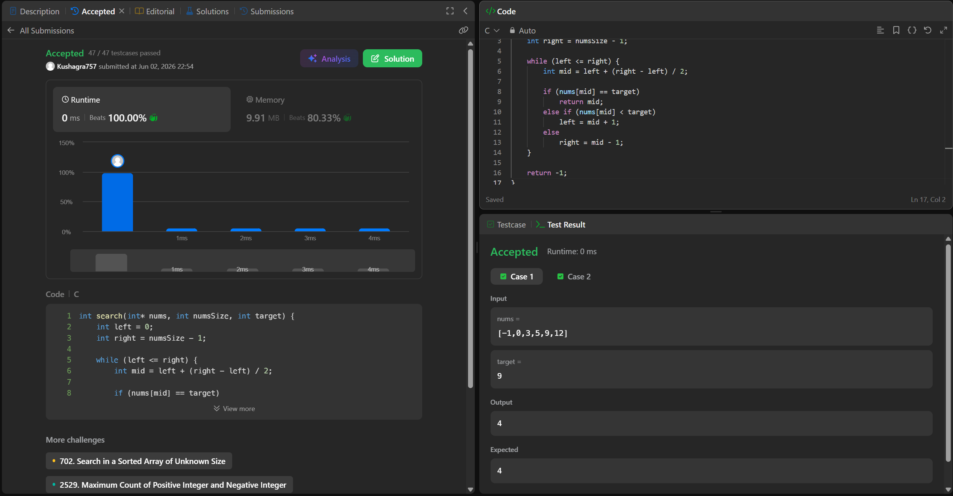

LeetCode Problem:268
Given an array nums containing n distinct numbers in the range [0, n], return the only number in the range that is missing from the array.

Code:

int missingNumber(int* nums, int numsSize) {
int expectedSum = numsSize * (numsSize + 1) / 2;
int actualSum = 0;

for (int i = 0; i < numsSize; i++) {
actualSum += nums[i];
}

return expectedSum - actualSum;
}

ScreenShot from LeetCode:

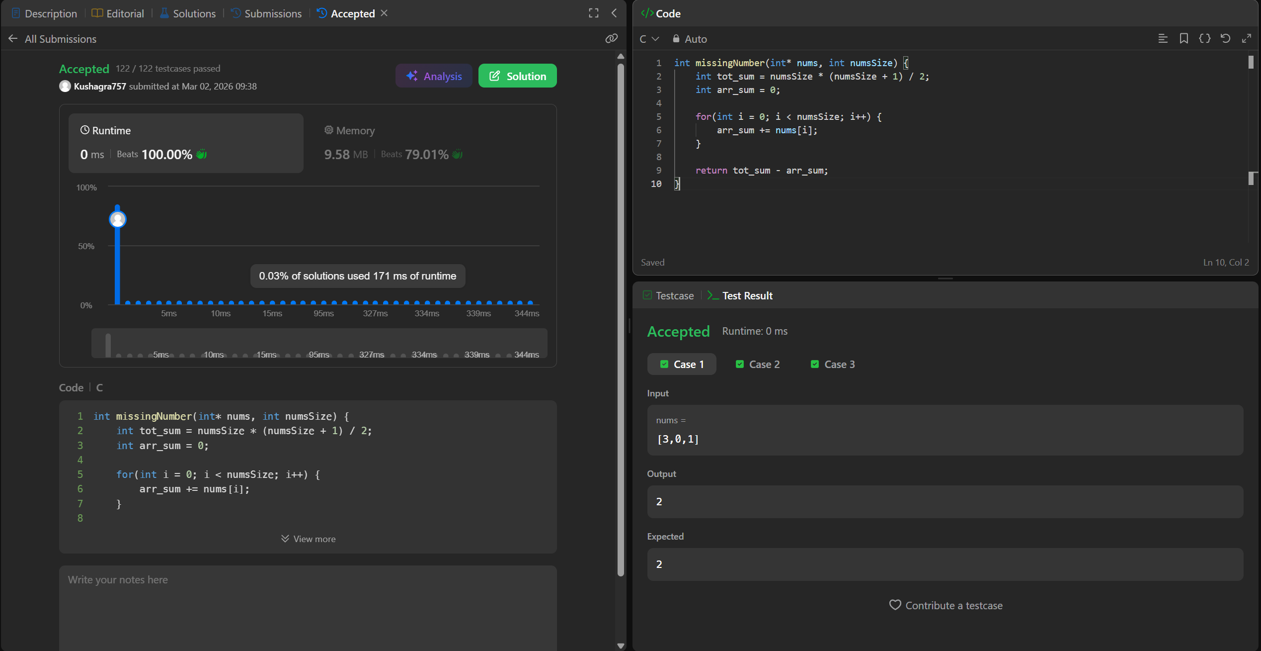

LeetCode Problem:1636
Given an array of integers nums, sort the array in increasing order based on the frequency of the values. If multiple values have the same frequency, sort them in decreasing order.
Return the sorted array.

Code:

int* frequencySort(int* nums, int numsSize, int* returnSize){
*returnSize=numsSize;
int* answer=malloc(numsSize * sizeof(int));
int hash[201]={0};
for(int i=0;i<numsSize;i++){
hash[nums[i]+100]++;
}
int temp;
for(int i=0;i<numsSize;i++){
for(int j=0;j<numsSize;j++){
int fi=hash[nums[i]+100];
int fj=hash[nums[j]+100];
if(fi<fj||(fi==fj&&nums[i]>nums[j]))
{
temp=nums[i];
nums[i]=nums[j];
nums[j]=temp;
}
}
}
return nums;
}

ScreenShot from LeetCode:
